Making a Custom Design for a T-shirt

There are multiple options available in the Knowledge Lab for how to place a custom design on fabric.

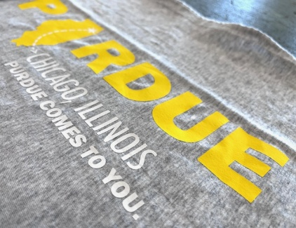
Heat Transfer Vinyl (HTV)
HTV is a thin material that fuses to the surface of the fabric.

Option 1: Solid Color Sheets of HTV
- Used with Cricut machines.
- Best for designs made of solid color, simple shapes and forms.
- Can be used on any fabric of any color.
Option 1: Solid Color HTV

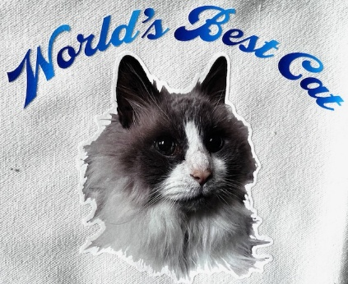
Option 2: Printable HTV
Option 2: Printable HTV
- Printed with Roland Sticker Vinyl Printer, requires a reservation.
- Best for complex designs of multiple colors and imagery.
- Can be used on any fabric of any color.

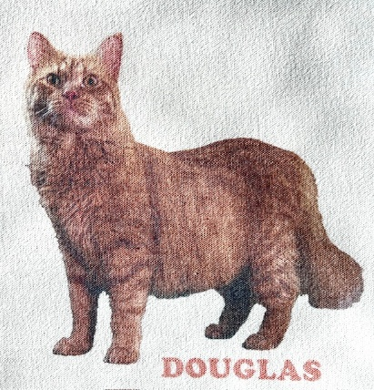
Dye-Sublimation
Option 3: Dye-sublimation
- Heat activated ink-transfer process using Sawgrass Sublimation printer.
- Can be used for any kind of design.
- Can only be used on light-colored fabric that is 65%-100% polyester.

Heat Transfer Vinyl (HTV)

The Knowledge Lab offers two HTV options:
Solid color sheets cut with a Cricut machine.
Printable HTV printed with the Roland sticker vinyl printer.
Both work on cotton, polyester, or cotton/poly blends, and on any fabric color.

Solid Color HTV (Cricut Maker 3)
- Best for simple shapes and solid colors (see examples below).
- Works on cotton, polyester, or blends (any color).
- Designs can be created directly in Cricut Design Space program or files can be uploaded.
  - File formats: SVG or PNG with transparent background preferred; JPEG can be used but may not translate correctly in the design program.
- Design limits: avoid fine lines; text must be at least 1/4 inch tall.


- Maximum lab material limit: 12x24 inches per month for individuals and groups; bring your own if more or specific colors needed.
Two color design
Three color design, layered
Single color design


Steps
- Create or upload a design to the Cricut Design Space program.
- Place HTV on mat, cut with Cricut (Fig. 1)
- Weed (remove excess vinyl), leaving only the design on the adhesive backing (Fig. 2 & 3).
- Heat press design using lab’s temperature/time chart (Fig. 4)
- Cover with butcher paper; press.
- Remove adhesive sheet per HTV instruction (Fig. 5).
- Press again for 5 second to finish (Fig. 6)
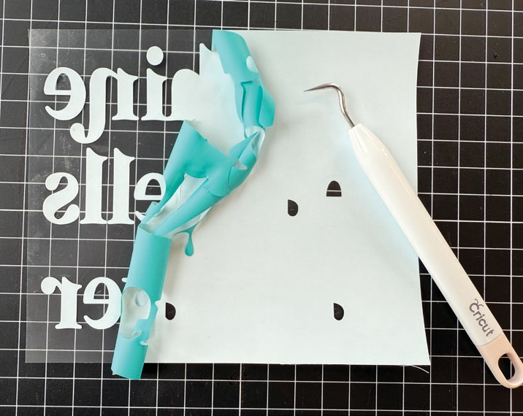
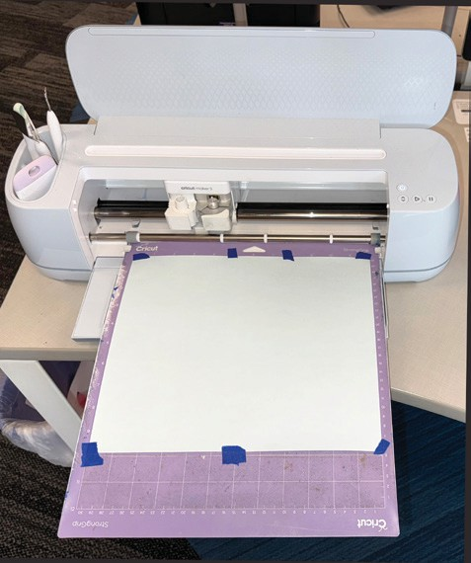
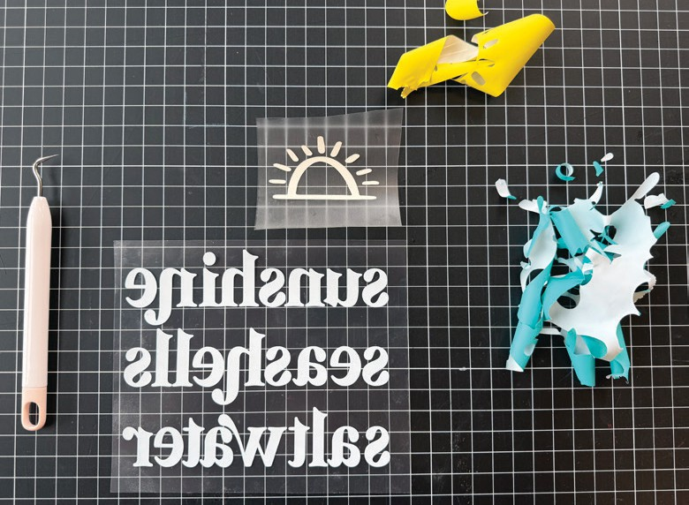
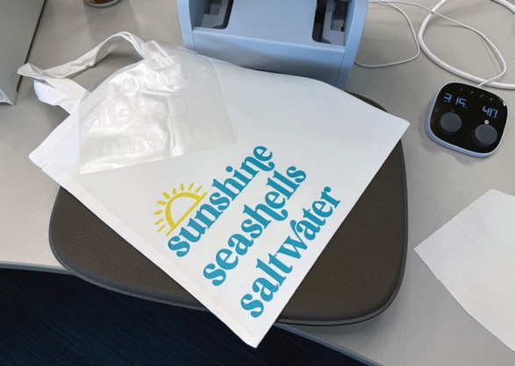
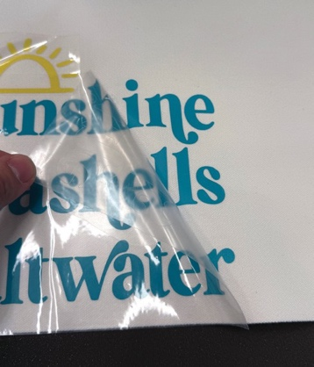
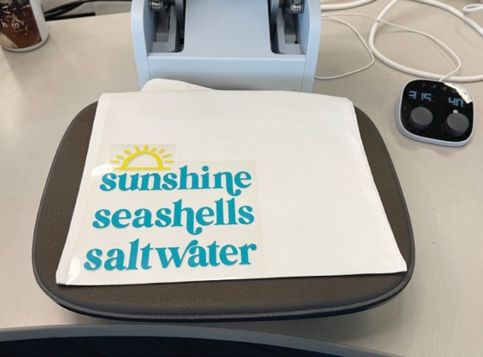
Figure 2
Figure 2
Figure 3
Figure 6
Figure 5
Figure 4

Note: The Knowledge Lab provides HTV color sheets with a monthly limit of 12×24 inches per person or group. Colors are not guaranteed. For larger projects or specific colors, bring your own HTV—available in sheets or rolls from any brand, as long as it’s labeled “heat-transfer vinyl” or “iron-on vinyl.”
HTV can be ordered online from retailers like Amazon or arts and craft stores like Michaels.

Printable HTV (Roland Sticker Vinyl Printer)
- Best for complex, multicolor, or photo-based designs.
- HTV is white- negative space in a design will be white. In the example below, where there is no color, will be white (Fig. 7)
- Cannot cut very fine lines, designs and text may need an offset outline (Fig. 8).
- Requires Adobe Illustrator for file prep and a reservation (1-2 days in advance).
  - Note: Files can be denied if not prepared correctly.
- Maximum lab material limit: 18x36 inches per month for individuals and groups.
- No mass production. Avoid copyrighted images unless permitted or public domain/Creative Commons.
  - Note: Files can be denied if there is copyright infringement. Use your creativity! That is the purpose of using the Knowledge Lab.
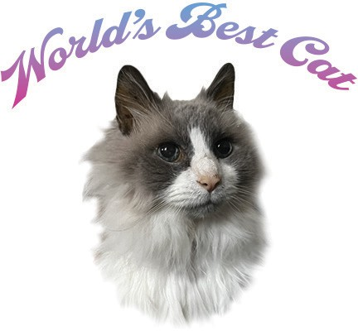
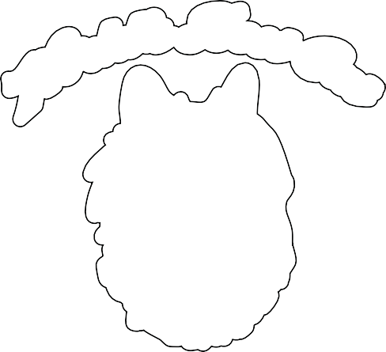
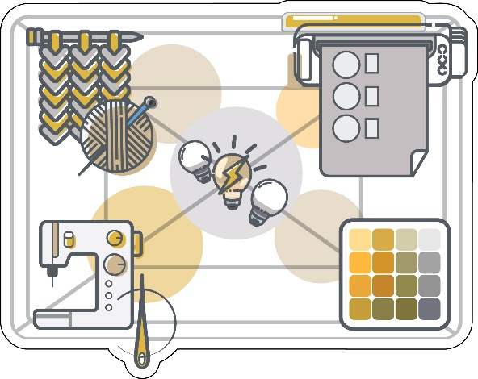

Figure 8: Design with offset path around text and image
Figure 7: Design empty space (negative space) around elements- the background will be white.

Note: The sticker printer requires preparing your file in Adobe Illustrator and submitting a reservation. See A Guide to Sticker Printing in the Knowledge Lab for lab locations with Illustrator, file prep steps, and the reservation form. The monthly limit is 18×36 inches per person or group. For larger runs, use a commercial printer.

Steps
- Prep file in Illustrator; follow file prep guide.
- Submit reservation form (select “Heat Transfer” as material).
- If reservation is approved, arrive at start of reservation time and confirm print with staff.
- When print is complete (Fig. 9), weed excess vinyl, leaving only the design on clear backing (Fig. 10 & 11).
- Apply transfer tape; burnish and remove HTV backing (Fig. 12 & 13).
- Heat press with butcher paper (using lab’s temperature/time chart, Fig 14).
- Remove adhesive sheet (Fig. 15); press again for 5 seconds (Fig. 16)

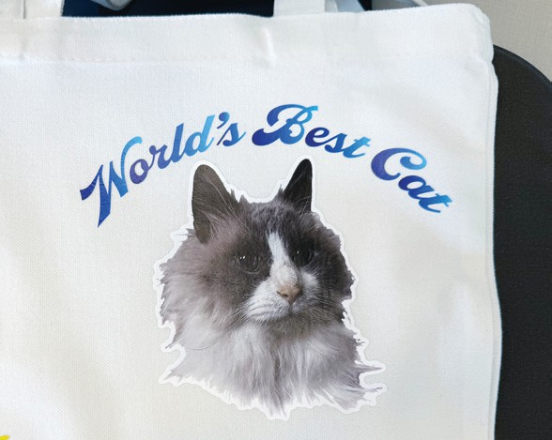
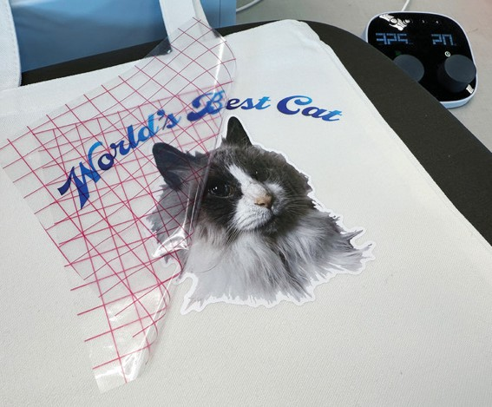
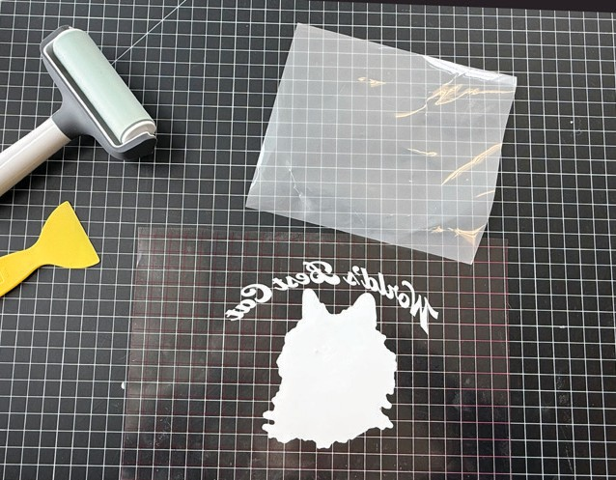
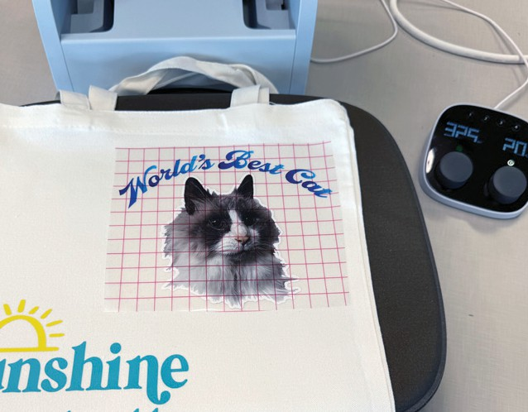
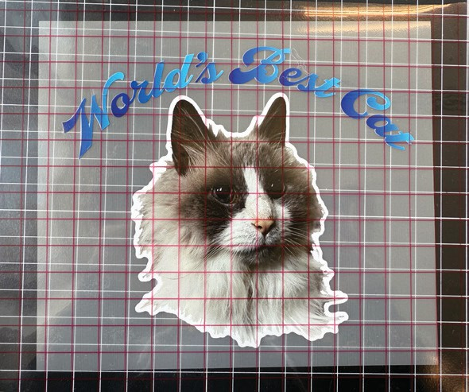
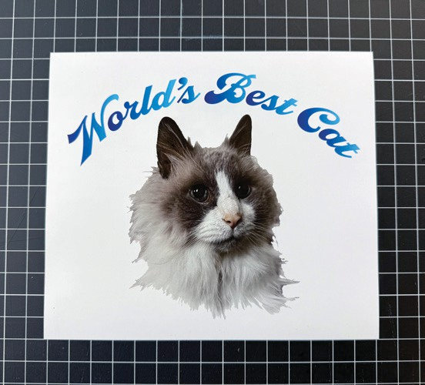
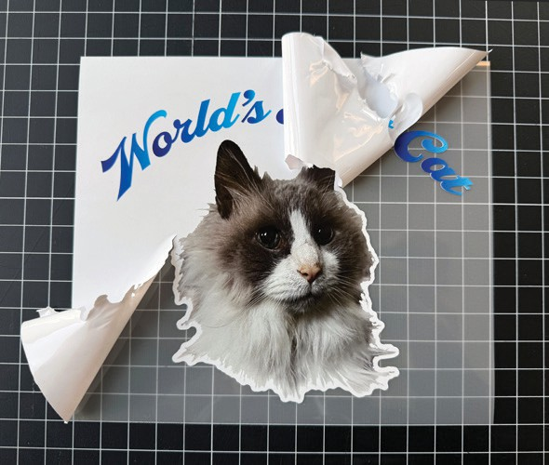
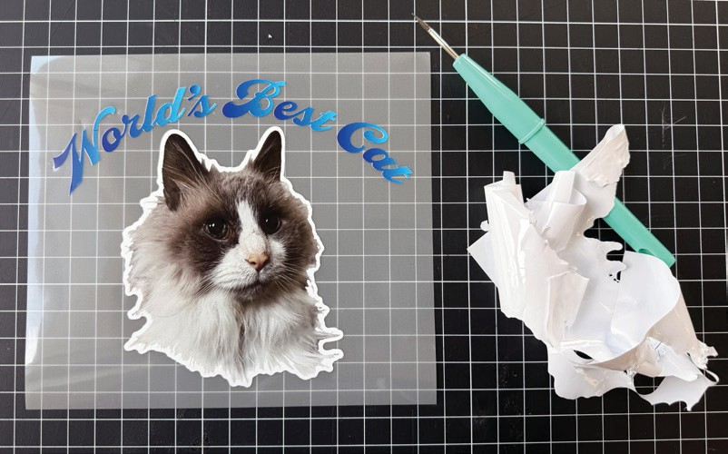
Figure 16
Figure 15
Figure 13
Figure 14
Figure 12
Figure 11
Figure 10
Figure 9

Dye-Sublimation
This method transfers your design directly into the fabric using special ink and transfer paper with a heat press. It produces full-color images and fine details but works only on light-colored fabric with at least 65% polyester—not on dark fabrics or 100% cotton. No cutting or transfer tape is required.
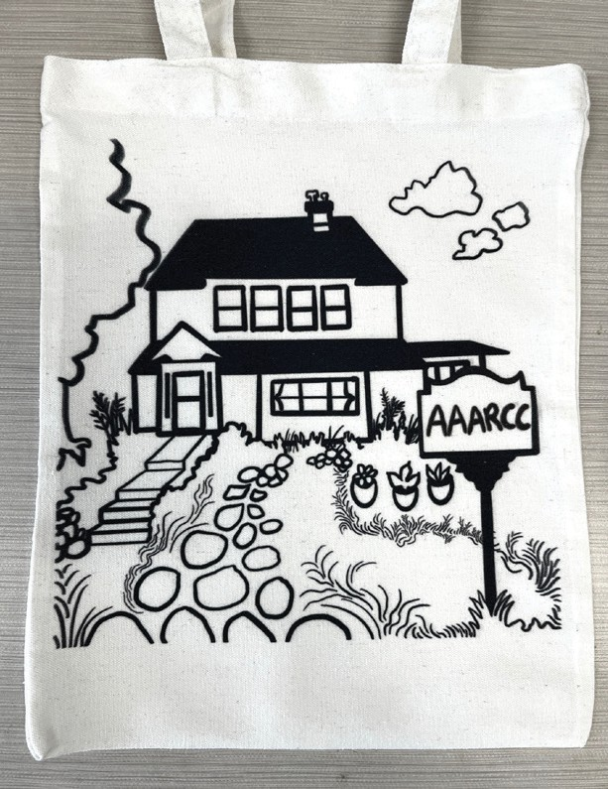
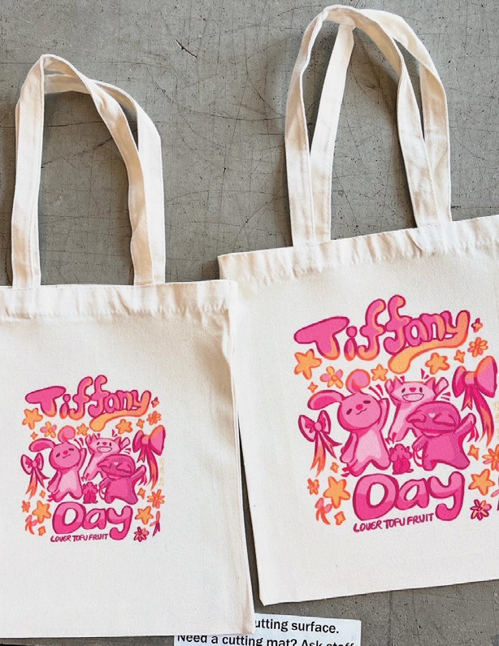
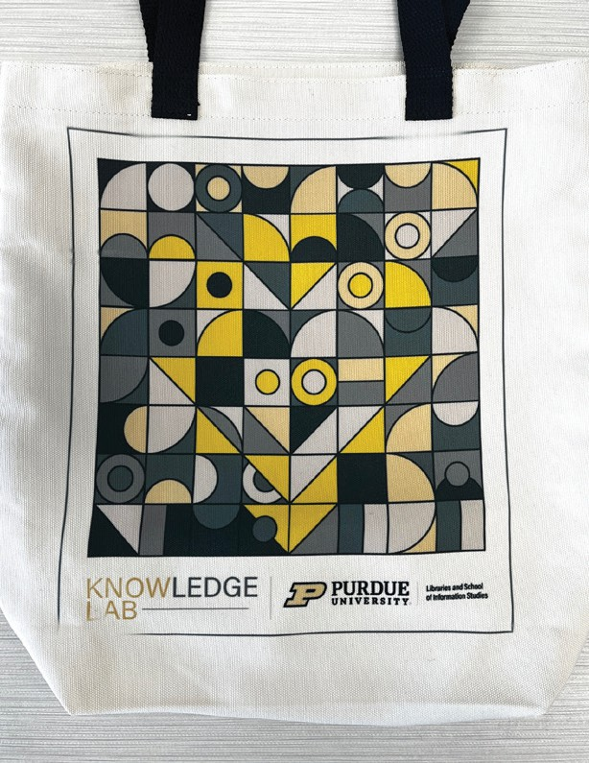

- Paper sizes in the lab: 8.5x11in and 11x17in.
  - Avoid printing designs larger than the 11x15in heat press.
- Maximum lab material limit: 10 sheets (any size) per month for individuals and groups.
- Waste reduction tip: Combine multiple designs on one sheet when possible.
- Bring your own paper if you need more than the limit (e.g., A-Sub or Sawgrass TruePix).
  - If using your own paper: Limit 20 prints per month.

Printing Process:
Use the Sawgrass Sublimation Printer and Print Utility software (no reservation needed). The printer accepts JPEG, PNG, PDF, and TIFF files. Resize images in the program or in software like Photoshop. Lab staff can assist with setup and file preparation.

Steps
- Upload file to Sawgrass Print Utility; resize as needed and print.
  - Note: Printed designs will be mirrored and appear faded but will look correct full-color after transfer (Fig. 17).
- Heat press setting using lab’s temperature/time chart.
- Tape design to fabric with heat-resistant tape (Fig. 18).
- Use butcher paper on top and underneath material to protect press and prevent transfer through other side of fabric.
- Press, then remove paper when cool enough to handle (Fig. 19).
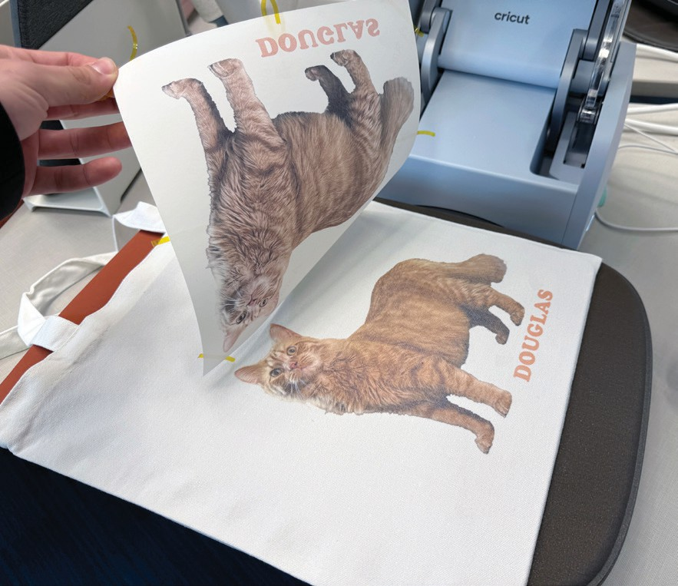
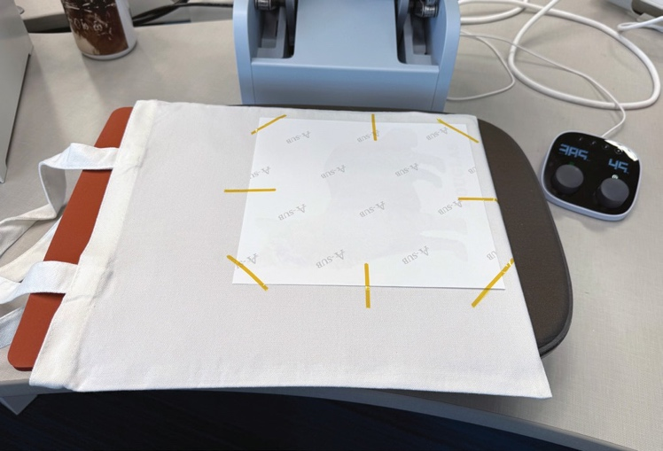
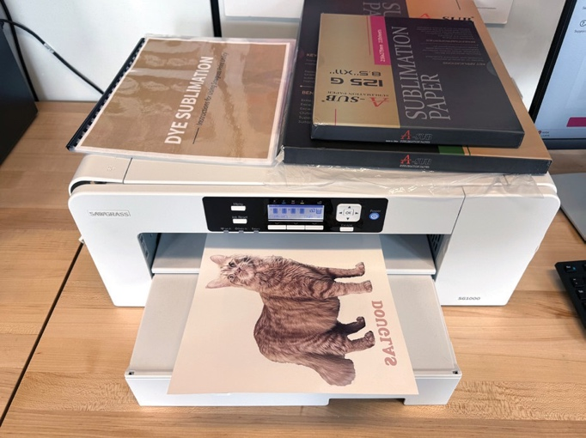
Note: Sublimation uses high heat- use gloves or wait for fabric to cool before handling. Do not repress prints, reuse sublimation paper, or reuse butcher paper with transferred ink
Figure 19
Figure 18
Figure 17

